**SKILL/JOB RECOMMENDER**

### 1 INTRODUCTION

**1.1 Description**

To develop an end to end web application capable of displaying the current job openings based on the skillset of the users. The users and their information are stored in the Database. An alert is sent when there is an opening based on the user's skillset. The user will interact with the chatbot and can get recommendations based on his skills. We can use job search API to get the current job openings in the market which will fetch the data directly from the webpage.

**1.2 Purpose**

Having lots of skills but wondering which job will best suit you? Don’t need to worry! we have come up with a skill recommender solution through which the fresher or the skilled person can login and find the jobs by using the search option or they can directly interact with the chatbot and get their dream job.

### 2 THEORETICAL ANALYSIS

**2.1 Block diagram Diagrammatic overview of the project.**

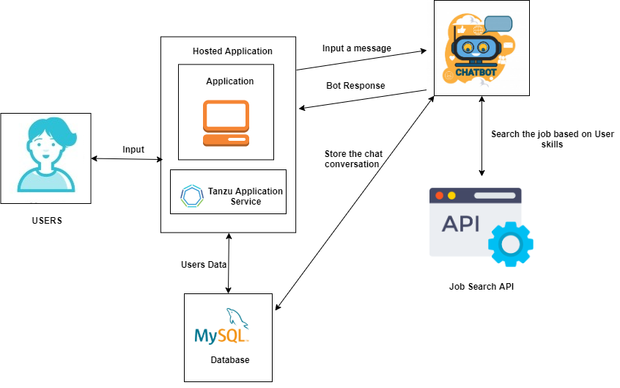

**2.2 Hardware / Software**

Hardware requirements: Working PC, internet connection

Software requirements: HTML, Bootstrap, MySQL, Springboot, Cloud Foundry, Tanzu Application Service, REST API's

**Project Description:**

### 3 EXPERIMENTAL INVESTIGATIONS

1. Understanding how to insert and fetch data from MySQL
2. Understanding how to work with APIs - fetch response from various APIs and parse the response they returned (mostly in .json format)
3. Learning how to style using HTML and CSS
4. Learning how to build images, and use existing images from hub.docker.com

### 4 ADVANTAGES

1. A recommendation engine can bring traffic to your site. It accomplishes this with customized e-mail messages and targeted blasts.
2. Consumers end up being more engaged in the website when individualized item recommendations are made. They are able to dive even more deeply into the product line without needing to carry out search after search.

### 5 CONCLUSION

This end to end web application capable of displaying the current job openings based on the skillset of the users. The users and their information are stored in the Database.An alert is sent when there is an opening based on the user's skillset. The user will interact with the chatbot and can get recommendations based on his skills. We can use job search API to get the current job openings in the market which will fetch the data directly from the webpage.

### 6 FUTURE SCOPE

Enhancements that can be made in the future:

1. UI Improvement
2. Scaling the application to handle more requests
3. Building mobile app for mobile users.

### 7 BIBLIOGRAPHY

[1]<https://www.w3schools.com/html/> - W3schools html guide

[2]<https://www.w3schools.com/w3css/defaulT.asp> - W3schools CSS

[3][https://smartinternz.com/Student/badge_workspace](https://smartinternz.com/Student/badge_workspace/9775) - SmartInternz dashboard